1. Account Creation & Contract Signing
- Account Setup: Clients create an account with email, password, and basic contact details.
- Welcome Page: After logging in for the first time, clients are greeted with a personalized welcome message.
- Contract Selection & Signing: Based on your selection, clients are presented with one of 3 contracts to review and sign. The contract page includes:
  - Dynamic Contract Display: Admin can choose which contract to assign to each client.
  - E-signature Integration: Clients can sign the contract digitally.
  - Confirmation & Storage: Signed contracts are stored in the client’s document center, and a copy is sent to both the client and your team.

2. Onboarding Form
- Post-Contract Onboarding: After signing the contract, clients are directed to the onboarding form.
- Form Sections:
  - Personal Information: Name, address, phone number, email, date of birth, etc.
  - Business Information: Business name, type, industry, address, tax ID, years in operation, revenue, etc.
- Auto-Save Functionality: The form auto-saves progress to prevent data loss.
- Submission Confirmation: Upon submission, clients receive a confirmation message, and your team gets notified.

3. Dashboard
- Progress Tracker: A visual representation of the client's journey through different milestones:
  - Milestone Indicators: Clear markers for each key phase such as “Contract Signed,” “Onboarding Complete,” “Credit Repair in Progress,” and “Funding Secured.”
  - Progress Bar or Timeline: A graphical bar or timeline showing overall progress through the process, highlighting completed stages and what is yet to come.
  - Completion Percentage: Display the percentage of the process completed, giving clients an instant overview of where they stand.

4. To-Do List
- Task List: Display tasks needed for progress, such as “Upload ID Verification.”
- Progress Indicators: Clients can mark tasks as “In Progress” or “Completed.”
- Task Dependencies: Required tasks are marked as prerequisites for moving on to the next phase.
- Notifications & Reminders: Automated reminders for tasks with upcoming or missed deadlines.
- Document Uploads: Tasks requiring document uploads include an upload button for easy submission.

5. Credit Analyzer
Credit Report Overview:
  - Total Hard Inquiries: Summary of current hard inquiries across all three bureaus.
  - Card Utilization: Breakdown of credit utilization for each individual card.
  - Overall Utilization: Total credit utilization percentage across all accounts.
- Credit Score Tracker:
  - Three Credit Scores: Scores from Equifax, Experian, and TransUnion displayed with updates.
  - Score Change Graph: Visual graph showing credit score changes over time.
- Milestone Tracking for Hard Inquiries:
  - Removed Hard Inquiries: Track the number of removed hard inquiries with details by bureau and removal date.
  - Visual Indicator: Color-coded display for remaining and removed inquiries.
- Utilization Breakdown:
  - Per Card Details: Current balance, limit, and utilization percentage for each card.
  - Overall Utilization: Cumulative utilization ratio across all credit lines.
- Insights & Recommendations: Automated suggestions based on credit data to help clients improve their credit.

- The Credit Analyzer will display the client’s credit data in an easy-to-read format.
- Credit Scores Overview
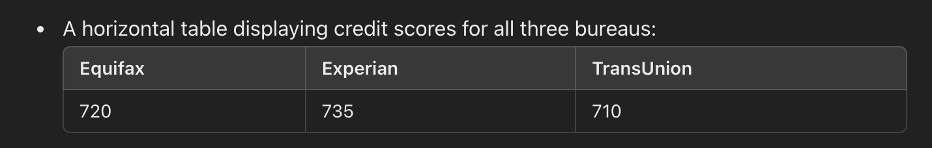
- Debt Tables:
- Mortgages
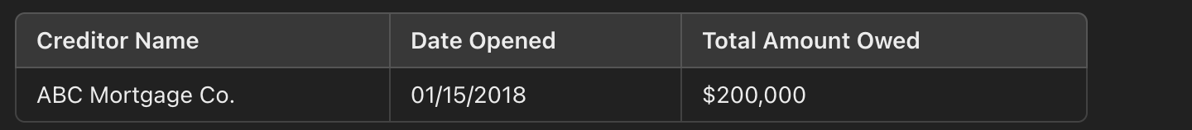
- Personal Loans:
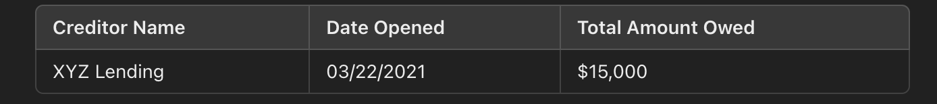
- Credit Card Utilization Table:
- A detailed breakdown of credit card data:
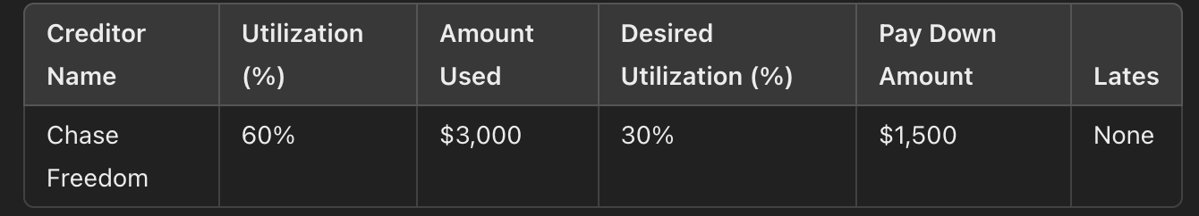

- Hard Inquiry Tables:
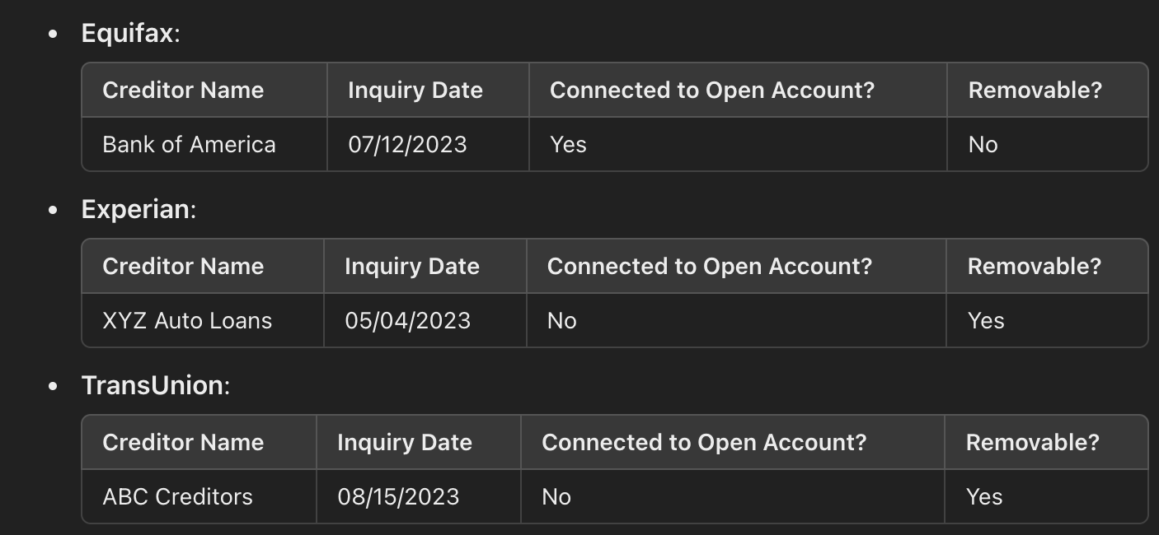
- Credit Overview Table (Last Credit Table):

- Summarizes key metrics of the client’s credit profile:
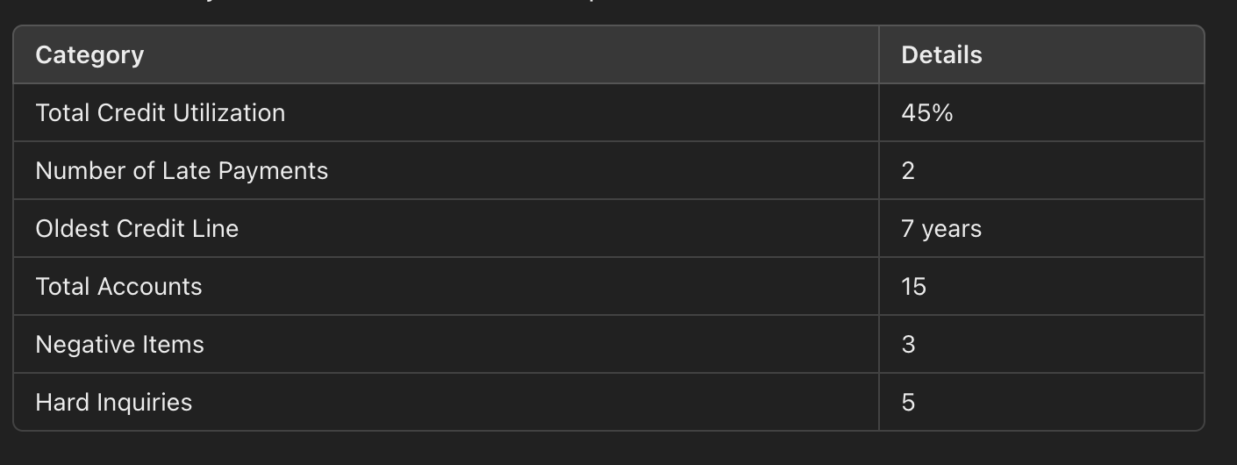

6. Funding Application Status
- Main Table Format:
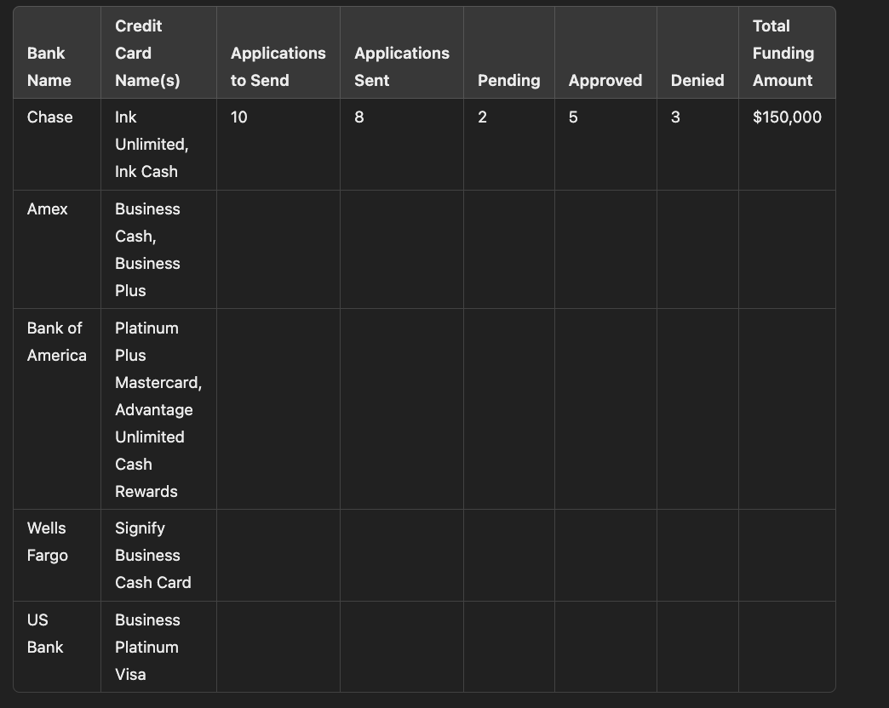
Summary Table: Below the main table, add an aggregated summary row with totals for each funding category.
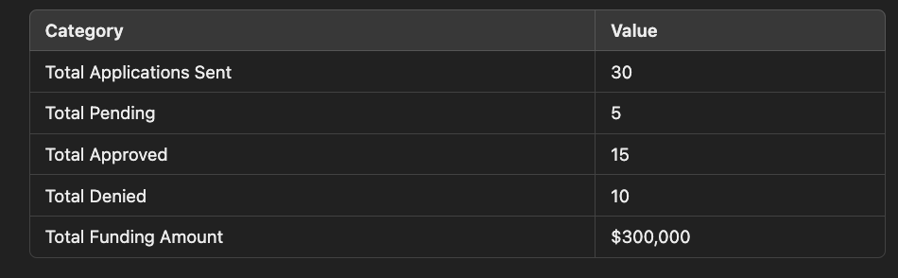

Note for Developer
- Client Control Restrictions: Clients will not have control over any aspect of the portal. All updates and changes will be managed manually by the admin

